Week 5 Visualization Activity

Jai Chi Cham

2022-09-17

##Histogram for variable avg_hatecrimes_per_100k_fbi “avg_hatecrimes_per_100k_fbi” displays the average annual hate crimes per 100,000 population as per FBI data. Timeframe is year 2010-2015. The histogram displays that the highest frequency of average annual hate crimes is range from 0-2 hate crimes per 100,000 population.The highest frequency is 25. Only one state has an average hate crime range from 10-12 per 100,000 population.

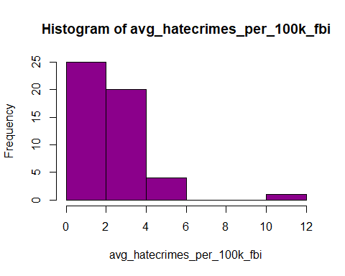

##Scatter plot displaying relationship between share_voters_vited_trump and avg_hatecrimes_per_100k_fbi The below scatter plot displaying relationship between average annual hate crimes per 100,000 population and the share_voters_vited_trump. The plot shows that states with higher share_voter_voted_Trump have higher average annual hate crimes per 100,000 population.

